Task 1:

I tried to design the system in a modular way, breaking down projects into smaller parts to allow them to perform different functions separately. For example, I tried to use the type of beverage to distinguish coffee and tea, because according to the description, sugar and milk can only be used for coffee, and the type distinction will be conducive to the availability of the method of adding sugar and milk. At the same time, it also prepares for the need to implement different brewing methods in the future. New drink types can also be added to DrinkType in the future when new drink types are added or removed.

In the brewing process, I also tried to manage the brewing methods of coffee and tea separately, but I think the current complexity is a little high, and variables and methods are often repeated, so the implementation process is simplified.

Task 2:

UML Class Diagram:

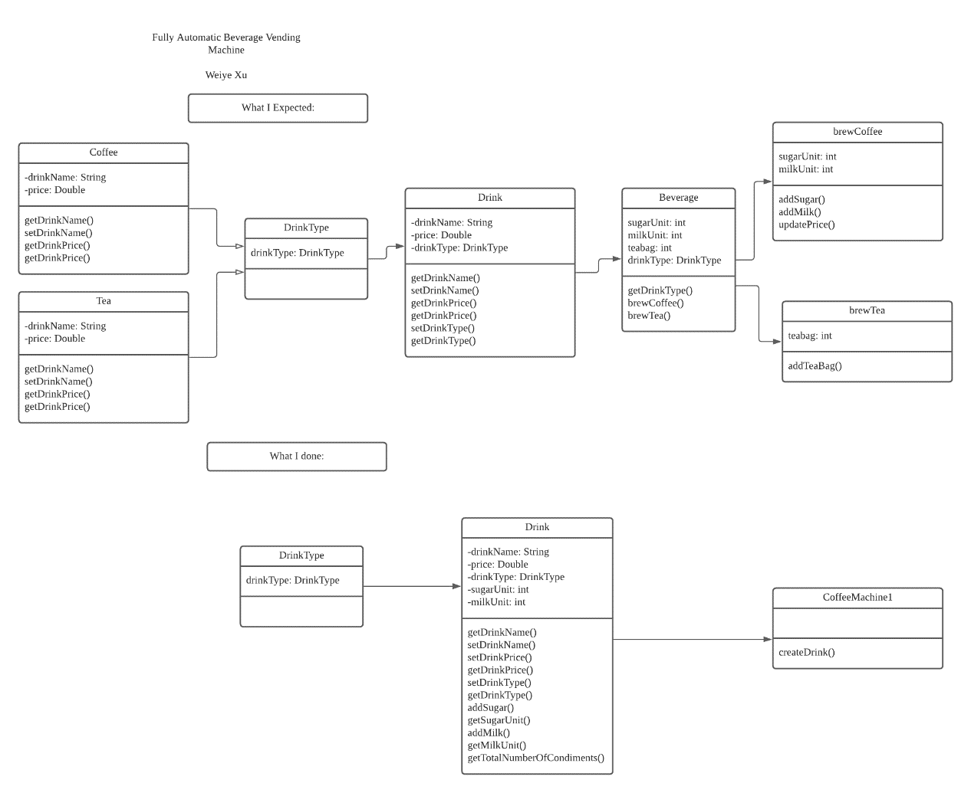

Task 3:

